

Managed Endpoint Security Services


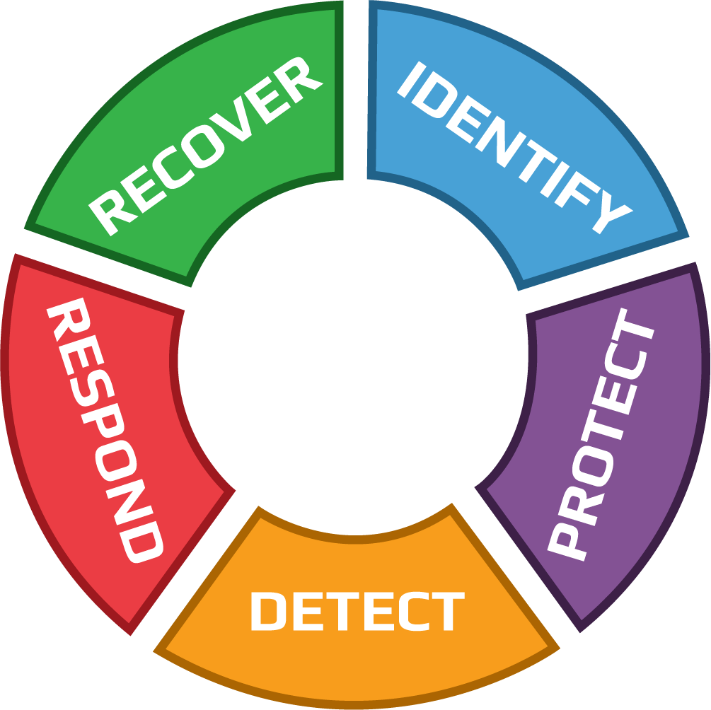

IDENTIFY

Managed Endpoint Identification Services
- Monthly and On-Demand NIST-Based Asset Management Report & Cyber Posture of Devices
- Device Cyber Lifecycle Management (Onboarding, Ongoing, and Offboarding)
- FCI NIST-Based Technical Control Standard Enforcement
- Automated Tools to Set and Capture Proper Configuration/Controls:
• On Desktops, Laptops, Servers, Virtual Servers, Smartphones & Tablets
• Enforced Without User Involvement
• Device Settings: Complex Password, Computer Firewall, Logs, Screen Saver, OS Patches, etc.
• Cyber Tools: Remote Monitoring, Full-Disk Encryption, Endpoint Protection (Antivirus, Anti-Malware, Anti-Ransomware, and Behavioral Analysis) with EDR (Endpoint Detection & Response) and SOC (Security Operation Center), Computer MFA
- Threat & Vulnerability Identification
- Options:
  - User Credential Management Recommendation and Configuration Support
  - Web Application Gateway to Private Data System
  - Correlation of Users, Devices & Web Applications with Private Data

PROTECT

Managed Endpoint Protection Services
- Data Loss Prevention through Managed Endpoint Protection:
  - Antivirus, Web Protection, Network Protection, Peripheral Protection, etc.
  - Malware Detection & Blocking
  - Full-Disk Encryption with Key Retention & Restoration Services
  - Data Leakage Protection with Content Filtering (Advanced Configuration)
- Email Encryption Guidance & Recommendations
- Mobile Device Management: OS version, status of enabled security features (configured or disabled), full disk encryption, mobile device biometrics (Face ID/Touch ID); screen lock or tampered (jailbroken).
- Multi-Factor Authentication to Access Endpoints
- Options:
  - Multi-Factor Authentication to Access Web Applications with Private Data
  - Data Backup
  - Disaster Recovery / Computer Image Backup

DETECT

Managed Endpoint Detection Services
- 24×7 Performance & Availability Monitoring
- 24×7 Cyber Threat Monitoring
- 24×7 Cyber Compliance Monitoring
- Endpoint Intrusion Detection & Prevention
- Security Incident Event Monitoring & Management
- Log/Data Aggregation
- Real-Time Security Alerts & Reporting
- Insider Threat

RESPOND

Managed Endpoint Response Services
- Active Automated Incident Response
- Cyber Expert Incident Response
- Mass Vulnerability Response for Imminent Risk (Zero-Day, etc.)
- Incident Response Support:
  - Documentation
  - Evidence Gathering, Preservation & Presentation
  - Cyber Incident Handling & Forensic Analysis During an Incident
  - Breach Determination

RECOVER

Managed Endpoint Recovery Services
- Automated Recovery Services
- Cyber Expert Recovery Services
- Options:
  - Full-Disk Encryption assistance for key recovery
  - Image Backup Restoration Recovery Services
  - Endpoint Password recovery

Endpoint Support Services
- Embedded Ticketing System for End-User Cyber Support
- Project Management

Endpoint Security Services Implementation

Included with the SERVICES
- Project management
- CISO/ISO support and training
- Cyber document templates
- WISP review and recommendations
- Cyber technicians for cyber tools installation, configuration, and testing
- End-user cyber support for FCI cyber tools
- Implementation with one CLIENT implementation team which members are also on the STEERING COMMITTEE (additional implementation with detached offices team are not included and shall be estimated)
- For additional CLIENT requests regarding implementation that are not included in this Section, FCI shall provide CLIENT with an estimate.

Timeframe
- Upon signature of the AGREEMENT, FCI shall have a maximum of 5 business days to send CLIENT (i) the first invoice, (ii) a welcome email, and (iii) instructions to access FCI Payment Portal for CLIENT to enter payment information and pay the first invoice.
- From the date the first invoice is paid, FCI shall have a maximum of 5 business days before the first implementation call.
- From the date of the first implementation call, FCI shall have a minimum of 2 weeks and a maximum of 2 months to complete the Implementation project.
- In the event that the implementation project is takes more than 2 months due to CLIENT, the situation shall be escalated to the STEERING COMMITTEE and FCI may charge additional setup fees to be estimated.

First Implementation call: WISP review and planning
- FCI and CLIENT jointly review the CLIENT WISP:
  - Screen Saver Enabled & Timeout
  - Event logging enabled
  - PC firewall enabled
  - Auto-updates enabled
  - Password Complexity
  - OS & Software Patches
  - Cyber Tools
- FCI and CLIENT jointly plan the CLIENT Launch Call to be done with all future users (management, staff, and advisors) and review/modify the presentation template to be provided by FCI. The CLIENT Launch Call shall include:
  - The SERVICES selected and not selected by CLIENT
  - The Cyber Support Services that are included and not included
  - The choice of CLIENT regarding approval of work for BILLABLE SUPPORT SERVICES
- FCI and CLIENT jointly review the email template to be sent to users to ask them to:
  - Click on the link to download the installer
  - Run the installer
  - Access the Support Portal to enter their contact information
- The installation shall not be initiated until all users are aware of the project and what is expected from them

Installation
- FCI configures the Endpoint Security installer and send the link to CLIENT
- CLIENT (with, if requested, an FCI representative) does the launch call with all users.
- CLIENT send the email with the installation link to all users.
- Users install the Endpoint Security software and enter their name in the Support Portal. It is critical that all users enter their name in the Support Portal so FCI knows who to contact in the case of an incident (the computer name is not always enough to identify the user).
- CLIENT is responsible to ensure that all users install the Endpoint Security and enter their name in the Support Portal. The Implementation project cannot continue until this step is finalized.
- Weekly, and on-demand, FCI shall provide an updated list of installed Endpoints.

Compliance Automation
When all users have installed the Endpoint Security software and enter their name in the Support Portal:
- Cyber Monitoring shall be activated.
- The WISP shall be automatically enforced on all Endpoints.
- Managed AVM (Antivirus & Anti Malware)
  - Antivirus shall be automatically installed, configured, updated and managed if no AVM is installed on the workstation.
  - Upon request, current Antivirus uninstall services are available and billed at the Level 1 hourly rate.
  - Option: Data Leak Protection configuration according to CLIENT requirements (USB and External Drives, File Content/Type/Name Filtering, email content, etc.)
- Managed FDE (Full Disk Encryption)
  - BitLocker on Windows 10 Pro (or more recent) and FileVault on Mac OS High Sierra (or more recent)
  - To encrypt the drive:
    - Automated encryption configuration is included for computers with TPM Chip.
    - For computers without TPM Chip, simple encryption instructions shall be given by FCI to CLIENT end-users, which are responsible to execute such simple encryption instructions.
  - When the drive is encrypted, FCI shall capture the encryption key, and store such encryption key in a secure location within FCI Cyber platform.
  - Optional support services not included in the SERVICES and charged per hour:
    - Workstation recovery assistance
- MFA (Multi-Factor Authentication)
  - MFA requires unique usernames
  - Each end-user is required to use the same username on all workstations used by such end-user.
  - MFA is installed and configured to allow access to computers.
  - MFA Advanced Configuration services to allow access for additional Web Applications are available and shall be billed.

Second Implementation call: NIST-Based Asset Management Report Review
- An inventory of all the assets and cybersecurity tools is provided with their configuration, version, etc.
- The report is sent monthly and on-demand.
- The NIST-Based Asset Inventory Report provides this information:
  - Last Check-in Time
  - Contact Name
  - Last Logged In User
  - Computer Name
  - Operating System Version
  - Antivirus Product
  - Antivirus Definition Status – Current or not
  - Antivirus Real-time Scan Status
  - Antivirus Status Date
  - Whole Disk Encryption Product
  - Whole Disk Status – Encrypted or Not
  - Whole Disk Status Date
  - Firewall Status – Enabled or Disabled
  - Password Complexity
  - Screen Saver Timeout (seconds/minutes)
  - Screen Saver Secure – Yes or No
  - Event Logging – Enabled or Disabled
- Discovery
  - A Network-Attached Device Discovery Report shall be provided to identify unknow devices such as computers, printers, servers, firewalls, mobile phones, VOIP, etc.
  - CLIENT may identify unknown devices in the NIST-Based Asset Management Report by naming them in the report and send the report back to support@fcicyber.com
  - Report and services for one location is included, additional locations are considered Advanced Configuration.
  - If requested by CLIENT to FCI, an Email alerts shall be sent to the CLIENT CISO when unknown devices are connecting to the network.
- Gaps are identified and discussed.
- FCI gives recommendations regarding Endpoint and Enforcement settings

Third Implementation Call: STEERING COMMITTEE (Optional)
- In the event that CLIENT requests it, a third call shall be scheduled in which the implementation team members from FCI and CLIENT shall present the NIST-Based Asset Inventory Report to the STEERING COMMITTEE and review recommendations and/gaps.

FCI Managed Network Services

FCI Managed Network Identification Services
- FCI NIST-Based Technical Control Standard Enforcement
- Automated Tools to Ensure Proper Configuration/Controls:
  - Firewall: No Opened Ports, No Remote Desktop Access, Logging Retention Period
  - Option: WiFi: Visible for Guest WiFi, Hidden for Staff & Advisors, Wired-Only Management
- Threat Identification

Managed Network Protection Services
- Security Awareness Training for Leadership (CEO, CISO, ISO, Train-the-Trainer, etc.)
- Data Loss Prevention through Managed Network Protection:
  - Firewall Patching & Updates
  - Network Content Filtering
  - Gateway SSL VPN configuration and training to one CLIENT or IT Firm employee. The trained person will add/delete users.
  - Data Leakage Protection

FCI Managed Network Detection Services
- 24×7 Cyber Threat Monitoring
- 24×7 Cyber Compliance Monitoring
- Network Intrusion Detection & Prevention
- Security Incident Event Monitoring & Management
- Log/Data Aggregation
- User Behavioral Analytics (UBA)
- Real-Time Security Alerts & Reporting
- Insider Threat

FCI Managed Network Response Services
- Active Automated Incident Response
- Cyber Expert Incident Response
- Mass Vulnerability Response for Imminent Risk (Zero-Day, etc.)
- Incident Response Support:
  - Documentation
  - Evidence Gathering, Preservation & Presentation
  - Cyber Incident Handling & Forensic Analysis During an Incident
  - Breach Determination

FCI Managed Network Recovery Services
- Automated Recovery Services
- Cyber Expert Recovery Services

FCI Network Support Services
- Phone & Email Cyber Support
- Ticketing System
- Project Management

- Security Training for Leadership (CEO, CISO, ISO, Train-the-Trainer, etc.)

